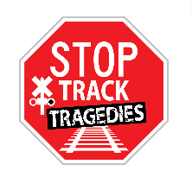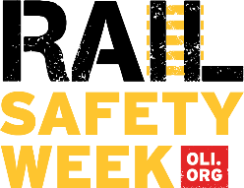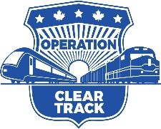

Overview – Rail Safety Week in North America

Operation Lifesaver, Inc. (OLI), the national rail safety education nonprofit partners with Operation Lifesaver Canada to mark the observance of Rail Safety Week (RSW) in North America during the last week of September each year. The U.S. Department of Transportation and other partner organizations support this nationally recognized effort to raise awareness and highlight the importance of rail safety education.

Rail Safety Week reinforces Operation Lifesaver’s mission to save lives. The goal of RSW is to raise awareness about the importance of rail safety and empower the general public to keep themselves safe near railroad crossings and along railroad rights-of-way.

The first U.S. Rail Safety Week was held September 2017, as OLI celebrated its 45th year and its mission of reducing collisions, fatalities and injuries at highway-rail crossings and preventing trespassing on or near railroad tracks. In 2018, Rail Safety Week was held jointly in Canada and the U.S. from September 23-29.

As part of RSW 2018, Canada Operation Lifesaver and OLI launched the "Stop Track Tragedies" public awareness campaign to show firsthand the impact of rail-related incidents on families – and within communities.

During RSW, each day focuses on a different safety theme to reinforce key safety messages for drivers and pedestrians. A schedule of events is shared on the RSW information page each year.

Law Enforcement Partners also take part in Rail Safety Week with an initiative called Operation Clear Track, which is held on the Tuesday of RSW. During Operation Clear Track, more than 500 local, state, federal and railroad police organizations are stationed at grade crossing and trespassing incident locations in 48 states to hand out safety materials to motorists and pedestrians and enforce crossing and trespass laws. In 2019, Canada OL joined the Operation Clear Track effort.

While the number of crossing collisions, deaths and injuries has dropped over the past five decades, it’s still a startling fact that about every three hours in the U.S., a person or vehicle is hit by a train. Together, we can #STOPTrackTragedies by increasing the awareness of rail safety all year round and bringing the message home during #RailSafetyWeek.

Join OL’s campaign by sharing the videos and other safety tips on social media using the hashtags #RailSafetyWeek and #STOPTrackTragedies. Follow Operation Lifesaver, Inc. on Facebook, Instagram, LinkedIn, Pinterest and Twitter for the latest information on rail safety.

-###-

